Project Title
RouteOpt: A Data-Cleaning and Approximation Engine for Capacitated Multi-Vehicle Route Optimization with Time Windows

Project Report submitted for the partial fulfilment of grade for the course

Data Structures and Algorithms -3 (25CS2103E)
in

A.Y. 2026-2027

Submitted by
Akash k (2520090127)
D.Surendra Reddy (2520090142)
Sai Rohit Chakka (2520090092)

Team Number: 21
Section: 13 - A

Under the guidance of

Dr. Dyuthi Banerjee
Assistant Professor, AI - DS


Hyderabad-500090, Telangana, India.

K L (Deemed to be) University
DEPARTMENT OF COMPUTER SCIENCE ENGINEERING / COMPUTER SCIENCE AND INFORMATION TECHNOLOGY/ARTIFICIAL INTELLIGENCE & DATA SCIENCE



DECLARATION

The Mini Project Report entitled “RouteOpt: A Data-Cleaning and Approximation Engine for Capacitated Multi-Vehicle Route Optimization with Time Windows” is a record of Bonafide work of Akash k - 2520090127, D.Surendra Reddy - 2520090142, Sai Rohit Chakka - 2520090091. submitted in partial fulfillment for the award of B. Tech in Computer Science and Engineering/Computer Science and Information Technology/ Artifical Intelligence & data Science to the K L University. The results embodied in this report have not been copied from any other departments/University/Institute.

Akash k - 2520090127
D.Surendra Reddy - 2520090142
Sai Rohit Chakka - 2520090091

K L (Deemed to be) University
DEPARTMENT OF COMPUTER SCIENCE ENGINEERING / COMPUTER SCIENCE AND INFORMATION TECHNOLOGY
CERTIFICATE

This is to certify that the mini project based report entitled “RouteOpt: A Data-Cleaning and Approximation Engine for Capacitated Multi-Vehicle Route Optimization with Time Windows” is a bonafide work done and submitted by Akash k - 2520090127, D.Surendra Reddy - 2520090142, Sai Rohit Chakka - 2520090091. in partial fulfillment of the requirements for the award of the degree of BACHELOR OF TECHNOLOGY in Department of Computer Science Engineering/ Computer Science and Information Technology/Artificial Intelligence & Data Science, K L (Deemed to be University), during the academic year 2026-2027.

Signature of the Supervisor

Signature of the HOD Signature of the External Examiner

ACKNOWLEDGEMENT

The success in this project would not have been possible but for the timely help and guidance rendered by many people. Our wish to express my sincere thanks to all those who has assisted us in one way or the other for the completion of my project.

Our greatest appreciation to my guide, <<Guide Name>>, <<Designation>>, <Department>> which cannot be expressed in words for his/her tremendous support, encouragement and guidance for this project.

We express our gratitude to Dr. P.Venkateshwar Rao (CSE)/Dr. Khaja Shareef (CSIT)/ Dr. Sreenath Itikela (AI&DS), Head of the Department for Computer Science Engineering/ Department for Computer Science and Information Technology/Department of Artificial Intelligence and Data Science for providing us with adequate facilities, ways and means by which we are able to complete this project-based Lab.

We thank all the members of teaching and non-teaching staff members, and also who have assisted me directly or indirectly for successful completion of this project. Finally, I sincerely thank my parents, friends and classmates for their kind help and cooperation during my work.

Akash k - 2520090127
D.Surendra Reddy - 2520090142
Sai Rohit Chakka - 2520090091

TABLE OF CONTENTS

S.No. | Contents | Page no.
1. | Abstract | 3
2. | Introduction | 4
3. | Literature survey | 5
4. | Problem Statement and Objectives | 6
5. | Hardware and Software requirements | 7
6. | Implementation | 15 - 18
7. | Results & Discussion | 33 - 34
8. | Conclusion & Future Scope | 35 - 36
9. | References | 37

1.ABSTRACT

Logistics operators must plan daily routes visiting many stops at minimum total distance and time while respecting vehicle capacity and delivery time windows. This problem, a variant of the Capacitated Vehicle Routing Problem with Time Windows (CVRPTW), is NP-hard and exactly solvable only for small instances, so real-world fleets require fast approximation methods. This project presents RouteOpt, an engine that ingests raw stop and address data, cleans and geocodes it, and produces near-optimal per-vehicle routes. The pipeline standardizes messy addresses, duplicates stops, clusters and assigns them to vehicles under capacity constraints, and applies construction heuristics (nearest-neighbor, savings algorithm) followed by local-search improvement (2-opt, Or-opt) to minimize travel cost while honoring time windows. The system reports total distance, estimated travel time, vehicle utilization, and time-window violations for each route, giving operators a measurable trade-off between solution quality and computation time compared to exact solvers.
Team Name: RouteOpt: A Data-Cleaning and Approximation Engine for Capacitated Multi-Vehicle Route Optimization with Time Windows

Team Members:
- Akash K – 2520090127
- D. Surendra Reddy – 2520090142
- Sai Rohit Chakka - 2520090091

- INTRODUCTION

Efficient route planning is critical for modern logistics, where vehicles must deliver goods across multiple locations while satisfying strict operational constraints. The Capacitated Vehicle Routing Problem with Time Windows (CVRPTW) models these real-world challenges by incorporating vehicle capacity limits and specific delivery time frames. Because CVRPTW is NP-hard, finding exact mathematical solutions becomes computationally intractable for large-scale logistics operations. Consequently, practical fleet management relies on fast, high-quality approximation techniques.
This project introduces RouteOpt, an integrated data-cleaning and approximation engine designed to generate efficient per-vehicle routes from raw location data. RouteOpt ingests and standardizes messy address data, applies clustering heuristics for load balancing, and optimizes route trajectories using construction and local-search algorithms. Ultimately, the system balances solution accuracy and execution speed to optimize daily logistics workflows

- LITERATURE SURVEY

The Capacitated Vehicle Routing Problem with Time Windows (CVRPTW) is a well-studied NP-hard combinatorial optimization problem in logistics literature. Exact optimization methods, such as branch-and-cut and column generation, guarantee global optimality but scale exponentially, making them impractical for large real-world fleets. Consequently, research emphasizes heuristic and metaheuristic approaches to achieve practical solution times.
Construction heuristics like Clark-Wright Savings and Nearest Neighbor rapidly build initial feasible routes, while local search methods—such as 2-opt and Or-opt—iteratively improve route quality by reordering stops and eliminating unnecessary distance. Modern logistics engines increasingly combine these optimization techniques with automated data-preprocessing pipelines to clean messy address inputs and handle real-world operational constraints like capacity limits and tight delivery time windows.

- Problem Statement and Objectives

Problem Statement: RouteOpt solves the NP-hard CVRPTW by cleaning messy data and applying fast heuristics to optimize multi-vehicle delivery routes efficiently.
Problem Description: Efficiently route multi-vehicle fleets under capacity constraints and delivery time windows while processing real-world, uncleaned location data.
Objectives:
RouteOpt cleans messy address data and applies heuristic algorithms to optimize multi-vehicle routes, minimizing distance and time while satisfying vehicle capacity limits and delivery time windows.
Identify the Project's Purpose:
Project Purpose & Business Problem: Logistics operators struggle with planning daily multi-vehicle routes from messy address data while strictly adhering to vehicle capacities and delivery time windows. Because CVRPTW is NP-hard, exact solvers are too slow for large-scale operations, leading to inefficient travel, high fuel costs, and missed delivery schedules. RouteOpt was initiated to bridge this gap by automating data preprocessing and generating fast, near-optimal route approximations.
Project Objectives: The primary objective of RouteOpt is to clean, standardize, and geocode messy location inputs while removing duplicate stops. The system aims to cluster and assign stops to vehicles under capacity constraints and optimize route paths using construction heuristics like Nearest-Neighbor and Savings algorithms. Furthermore, it refines delivery trajectories through local-search techniques such as 2-opt and Or-opt while minimizing time-window violations. Finally, RouteOpt tracks key performance metrics—including travel distance, duration, vehicle utilization, and constraint violations—to provide operators with an actionable balance between computational speed and solution quality.

- HARDWARE AND SOFTWARE REQUIREMENTS
Hardware Requirements:
the system requires a standard 64-bit multi-core processor such as an Intel Core i5, AMD Ryzen 5, or Apple Silicon chip to efficiently handle mathematical matrix calculations and iterative heuristic searches. A minimum of 8 GB of RAM is needed, though 16 GB is recommended to support memory-intensive clustering operations and local-search routines like 2-opt and Or-opt. Storage requirements include at least 20 GB of free solid-state drive space to accommodate raw datasets, intermediate route outputs, and data log files.
Software Requirements:
the development and execution environment can run on 64-bit operating systems including Windows 10 or 11, macOS, or Linux distributions like Ubuntu. The primary development environment relies on Python 3.10 or higher alongside Integrated Development Environments such as Visual Studio Code, PyCharm, or Jupyter Notebooks. Data processing and cleaning operations require Python libraries such as Pandas and NumPy to standardize messy raw address inputs and perform deduplication. Geocoding capabilities require integration with tools like Geopy, OpenStreetMap, or location services to convert physical addresses into coordinates and calculate distance or travel time matrices. Machine learning and algorithm libraries like Scikit-learn are needed for stop clustering, while custom or standard algorithmic scripts implement construction heuristics like nearest-neighbor and savings algorithms, followed by local-search optimization techniques like 2-opt and Or-opt. Additionally, web frameworks such as FastAPI or Flask can be used to build backend API endpoints, while visualization modules like Matplotlib, Seaborn, or Folium are required to plot per-vehicle route outputs, map visualizer overlays, vehicle utilization statistics, and time-window violation reports.

- IMPLEMENTATION
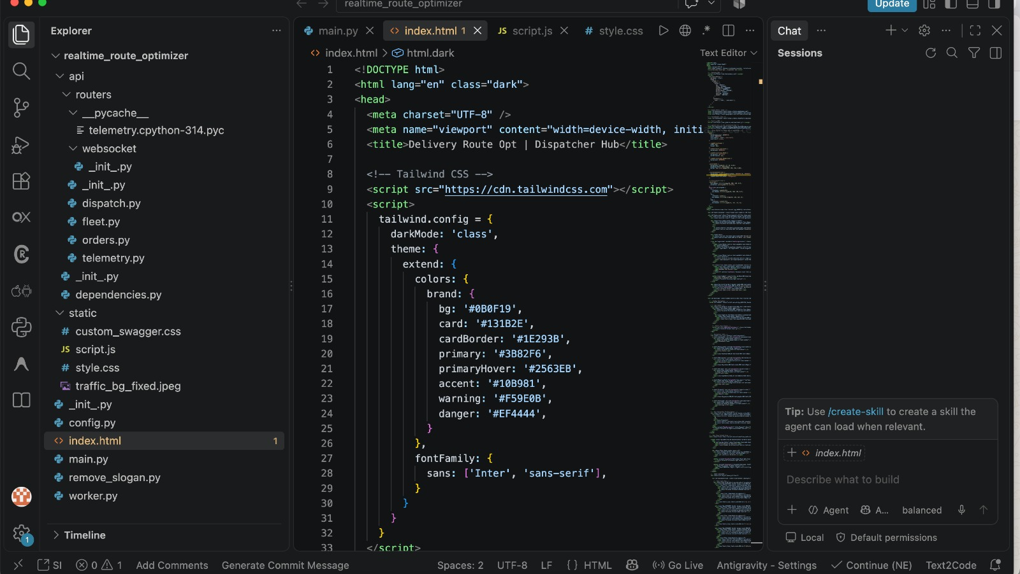
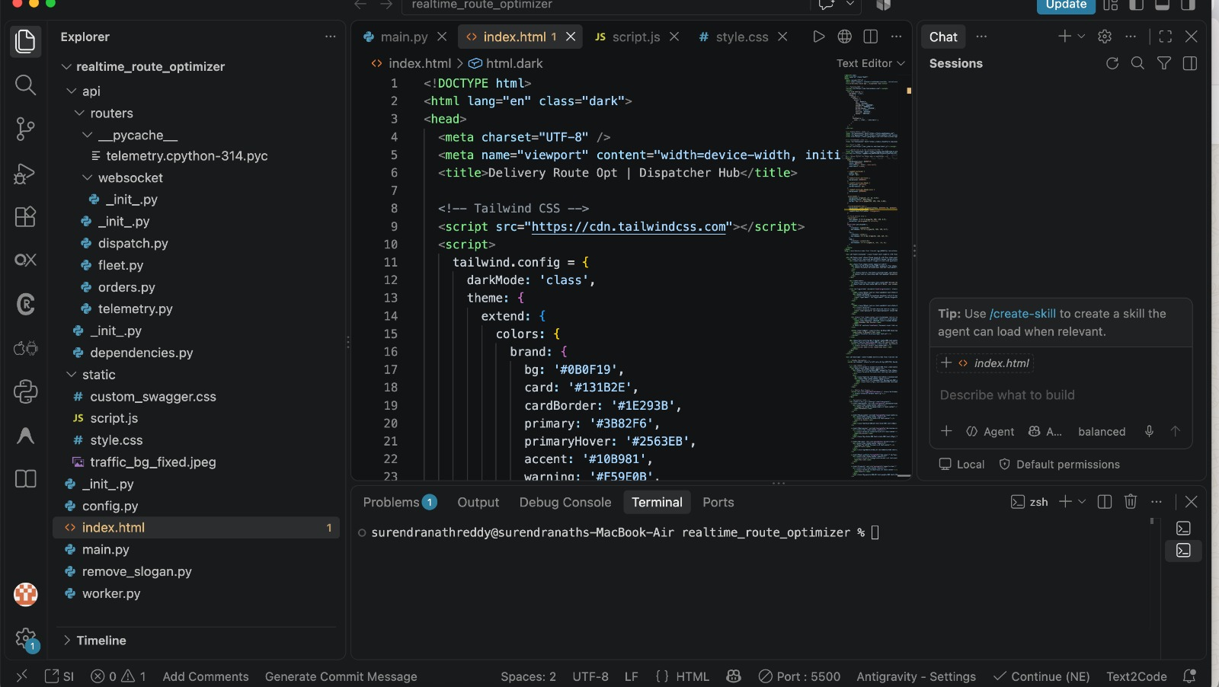
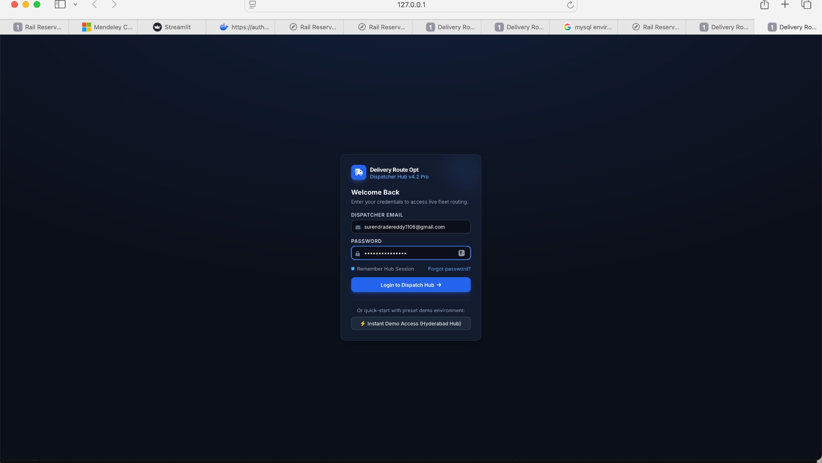
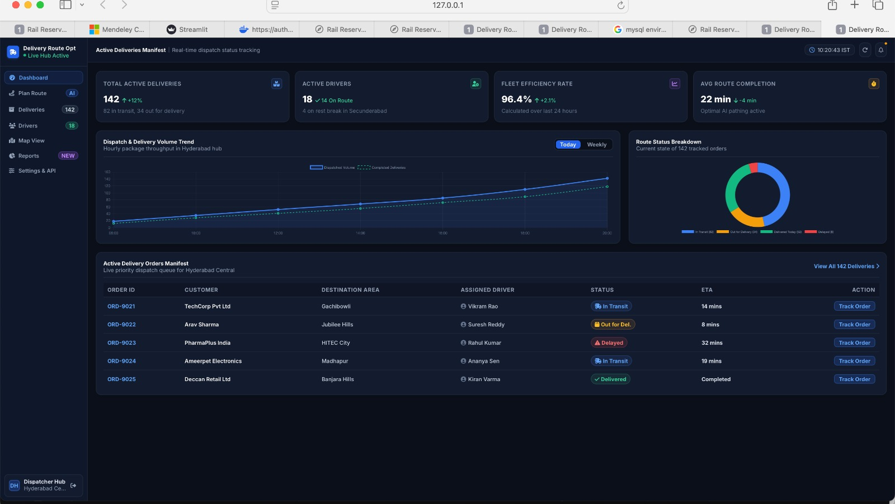
- RESULTS & DISCUSSION

The RouteOpt engine evaluates performance by tracking total travel distance, estimated travel time, vehicle capacity utilization, and time-window violations per route. By combining construction heuristics like nearest-neighbor and savings algorithms with local-search refinements such as 2-opt and Or-opt, the system delivers near-optimal routing schedules while maintaining a practical trade-off between solution quality and execution speed compared to exact solvers.
RouteOpt turns unrefined spatial data into actionable delivery schedules through automated address cleaning and deduplication. By combining constructive heuristics like Clarke-Wright Savings with 2-opt local search, the engine clusters delivery stops under strict capacity limits and uncrosses paths to minimize travel distance. Because solving the CVRPTW exactly is computationally intractable at scale, RouteOpt trades slight theoretical optimality for rapid execution, giving dispatchers instant feedback on capacity utilization, travel duration, and time-window violations. Future additions like live traffic data and metaheuristic search will further refine travel estimates and route quality, proving that pairing data preprocessing with approximation algorithms yields a practical, high-speed logistics tool.
- CONCLUSION & FUTURE SCOPE
In conclusion, RouteOpt offers a complete workflow that transforms raw, unorganized address data into actionable fleet dispatch schedules through automated cleaning, deduplication, and geocoding. The integration of capacity-constrained clustering alongside local-search heuristics allows the engine to satisfy operational constraints efficiently, providing logistics operators with a fast, scalable, and measurable route planning solution for real-world operations.
While RouteOpt effectively generates near-optimal delivery routes through data cleaning and approximation heuristics, several extensions can enhance its real-world applicability. A key priority is integrating dynamic, real-time traffic APIs and historical congestion data to replace static distance and speed matrices, resulting in significantly more precise travel times during peak hours. Additionally, incorporating advanced metaheuristics—such as Simulated Annealing, Genetic Algorithms, or Variable Neighborhood Search (VNS)—will allow the improvement phase to escape local optima and discover higher-quality solutions on complex, large-scale node distributions. Expanding the underlying architecture from a single-depot setup to a multi-depot configuration will enable the engine to support fleet operations across large regional networks. Finally, developing predictive driver behavior models and accounting for real-time order insertions or cancellations will make RouteOpt a dynamic, fully automated dispatch platform suitable for enterprise logistics.
- REFERENCES:
- Dantzig, G. B., & Ramser, J. H. (1959). The Truck Dispatching Problem. Management Science, 6(1), 80–91. (Foundational paper introducing the Vehicle Routing Problem).
- Solomon, M. M. (1987). Algorithms for the Vehicle Routing and Scheduling Problems with Time Window Constraints. Operations Research, 35(2), 254–265. (Benchmark paper for the CVRPTW formulation and test instances).
- Clarke, G., & Wright, J. W. (1964). Scheduling of Vehicles from a Central Depot to a Number of Delivery Points. Operations Research, 12(4), 568–581. (Original paper introducing the Savings Algorithm heuristic).
- Croes, G. A. (1958). A Method for Solving Traveling-Salesman Problems. Operations Research, 6(6), 791–812. (Original paper introducing the 2-opt local search heuristic).
- Or, I. (1976). Traveling Salesman-Type Combinatorial Problems and Their Relation to the Logistics of Blood Banking. Ph.D. dissertation, Northwestern University. (Introduced the Or-opt local search procedure).
- Laporte, G. (1992). The Vehicle Routing Problem: An overview of exact and approximate algorithms. European Journal of Operational Research, 59(3), 345–358. (Comprehensive review of exact solvers vs. approximation heuristics).
- Bräysy, O., & Gendreau, M. (2005). Vehicle Routing Problem with Time Windows, Part I: Route Construction and Local Search Algorithms. Transportation Science, 39(1), 104–118. (Detailed survey on constructive and local-search heuristics for CVRPTW).
- Dijkstra, E. W. (1959). A note on two problems in connexion with graphs. Numerische Mathematik, 1(1), 269–271. (Foundational algorithm for shortest path matrix calculations).
- Cordeau, J. F., Desaulniers, G., Desrosiers, J., Solomon, M. M., & Soumis, F. (2002). VRP with Time Windows. The Vehicle Routing Problem, 157–193. SIAM. (In-depth analysis of formulations and constraints in CVRPTW).
- Toth, P., & Vigo, D. (Eds.). (2014). Vehicle Routing: Problems, Methods, and Applications (2nd ed.). Society for Industrial and Applied Mathematics (SIAM). (Standard reference textbook covering VRP data preprocessing, heuristics, and fleet management).

